# If you are familiar with command input with terminals, ignore following notes.

The main difference between Windows and OS in this project relies in command input with terminals. There are basically three types of terminals-- built-in/universal command prompt in Win (or Terminal in OS), Anaconda (like a three-party universal terminal) and terminals within software. All these three types of terminals serve as platform for universal control over your computer. They vary a bit from each other. If some packages need to be installed under certain folder like our project folder, you will have to locate the folder first with universal terminals. But if you have already opened the folder with software, you can directly go to terminal within software to install packages (no need to locate your folder). So for universal installation of Django or version check, we use universal terminals. For necessary packages within software Pycharm or VScode, we use within-software terminals. For Win, it is better to install Anaconda instead of using built-in command prompt (cmd).

# Mark meanings

**Visual Studio Code** ----Software/package name

node-v12.18.1-x64.msi ----file/menu/button name

node –v ----code input

# Basic environmental settings

1. Install **Visual Studio Code**

2. Install **Pycharm** - professional version

During installation, check all boxes (esp environmental parameters)

3. Install **Node.js** v.12.18.1 or higher <https://nodejs.org/en/>

[https://nodejs.org/dist/v12.18.1/](https://nodejs.org/dist/v12.18.1/%20) find the right package for your PC

node-v12.18.1-x64.msi

During installation, check the box '...chocolately' (but it will automatically install Python39 which causes version conflict, make sure corresponding folders are deleted before next step)

To check, **cmd** to open **Command prompt**

node -v

4. Install **Anaconda** (automatically install Python 3.7/3.8)

5. Install **django** v.3.0.7 within Anaconda prompt or Pycharm

pip install django==3.0.7

6. Check **Python** version--3.7/3.8 (make sure there are not two different python versions)

**django** verison--3.0.7 (make sure there are not two different django versions)

Within Anaconda, input:

python --version

python -m django --version

---------------------------------------------------------------------------------

After completing basic/universal environmental settings for project running, we can start creating project files and install necessary packages within. It’s possible that other problems may occur, and unfortunately, we can’t include/prepare them all for you. When you are on your own, we suggest you trust in most Google answers. ∠( ᐛ 」∠)＿

----------------------------------------------------------------------------------

# Settings within software

1. Create a new folder Filename, open it and create a subfolder-site, open site with **VScode**

2. Click New terminal, input:

npm install -g create-react-app

npx create-react-app site

Hit enter and you should now see the processing.

3. Follow instructions that appear in terminal:

cd site

npm start

4. After observing an automatic browser popping up (React blue symbol) 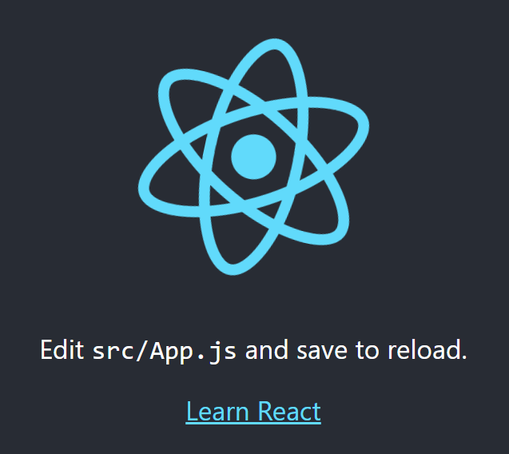, Ctrl+C to terminate batch job, start installing dependencies/packages in the terminal:

npm install @testing-library/jest-dom@4.2.4

npm install @testing-library/react@9.5.0

npm install @testing-library/user-event@7.2.1

npm install antd@4.4.3

npm install axios@0.19.2

npm install dynamic-antd-theme@0.6.1

npm install react@16.13.1

npm install react-dom@16.13.1

npm install react-dropzone@4.2.9

npm install react-highlight-words@0.16.0

npm install react-localize-redux@2.17.5

npm install react-redux@5.0.7

npm install react-router@4.2.0

npm install react-router-dom@4.2.2

npm install react-scripts@3.4.1

npm install [redux@4.0.0](mailto:redux@4.0.0)

Usually, it takes minutes.

During installation, 'npm start' to check if mistakes arise in the browser popping window.

Starting from 'npm install react@16.13.1', there will be 'scope' error which can be solved by adding import React from 'react' in App.js and App test.js but it will also be solved after you replace the whole src file in the next step.

5. Replace src file in your own project folder with src file provided

6. Input npm start in the terminal to see if there is a welcome page popping up, Ctrl+C in the terminal to stop

------------------------------------------------------------------------------------------------------------------------------------------

7. Open service file with **Pycharm**, go to settings-interpreter-choose Anaconda python exe

And also, you can check installation of right **Django** version in the directory.

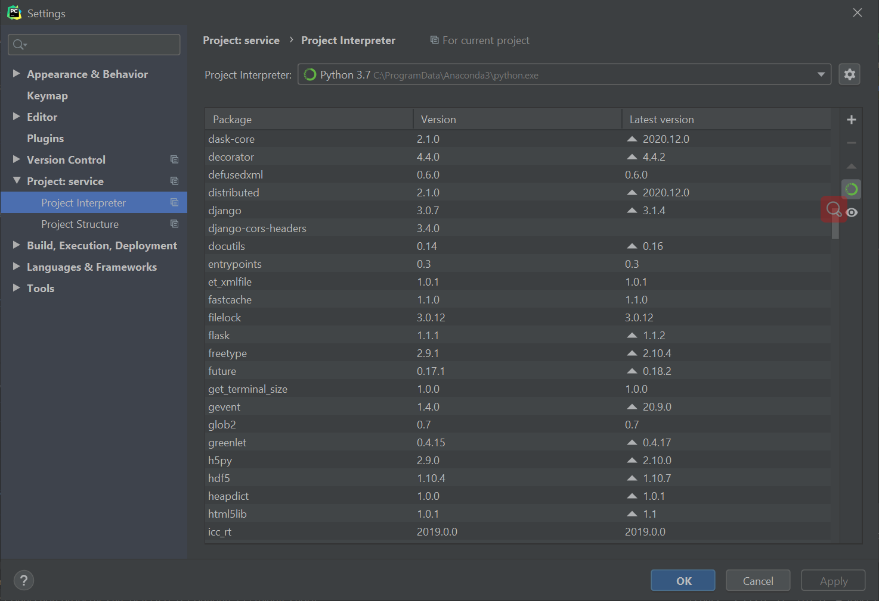

8. Go to edit configuration to choose the same interpreter for dj service, and check environmental settings.

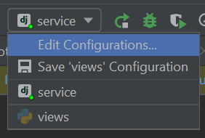

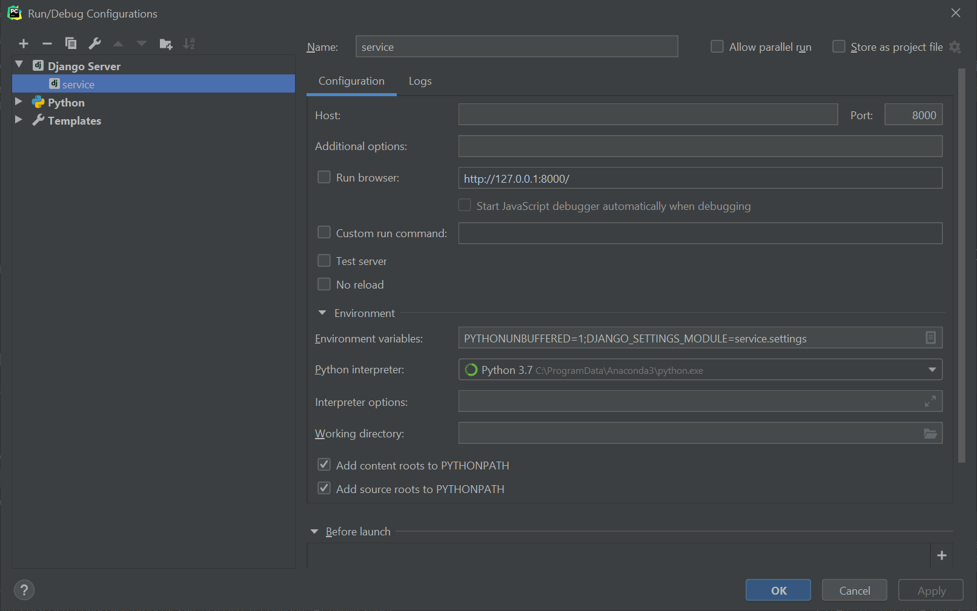

9. Run service (commonly located in upper right)

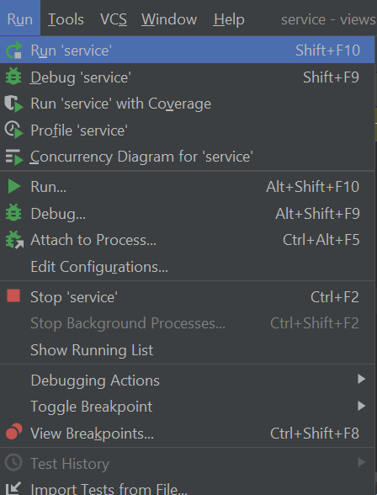

10. Several possible errors may occur, solutions can be (within **Pycharm** terminal):

Always make sure there is only one **django/python** version;

pip install -r requirements.txt (optional)

pip install django-cors-headers

pip install peakutils

11. Input npm start within **VScode** terminal again, and now you should see our ConjugateCalculator Online Welcome page

12. Ready to go!

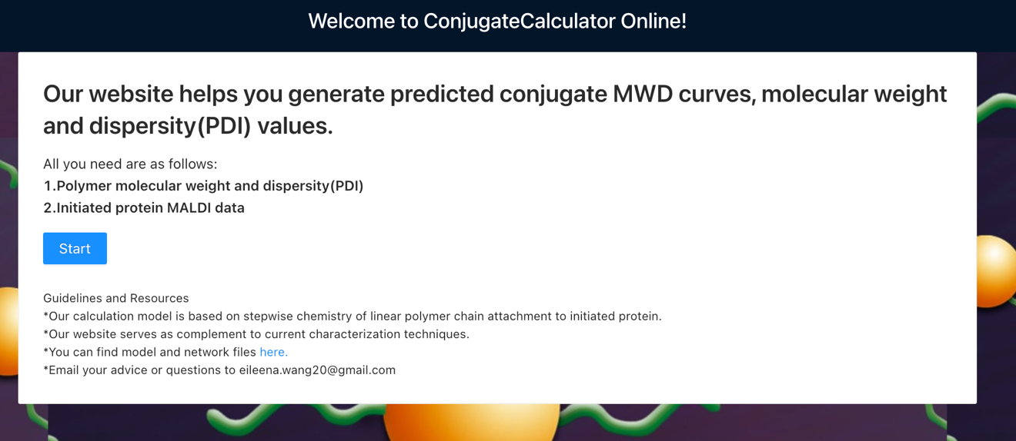

# Parameter input explanations

**Explanation on parameter -- Smoothfactor, Size of minimum calculation unit, Number of feeding data points:**

1. In our trials, no obvious difference of results when Number of feeding data points is over 1000

2. Increase Number of feeding data points or Smoothfactor will render better smoothness of combined curve without influencing results

3. Size of minimum calculation unit should be set to be 2 or 3 only

4. Increase in Size of minimum calculation unit or Number of feeding data points will cost longer computing time or even lead to memory failure especially when degree of initiator is near 20 and all corresponding weight percentages/mass ratios exist.

5. Smoothfactor is only suggested when huge increase in Number of feeding data points is impractical

6. Suggested settings for 10 initiators: Number of feeding data point:1000, Size of minimum calculation unit:2/3, Smoothfactor: 50

**Explanation on csv file (option1)**

Ideally, your csv file is generated by **Graph Grabber Software**

**Explanation on weight percentage (option 2)**

We have a built-in algorithm to check if the sum of your input weight percentages is not more than 1 and to automatically rearrange your inputs in initiator number order. Ideally, always make sure your inputs are reasonable and clear to track.

|  |  |  |
| --- | --- | --- |
|  | Number of initiators | Weight percentage (%) |
| Your inputs | 2 | 10 |
| 4 | 20 |
| 3 | 50 |
| After rearrangement | 1 | 0 |
| 2 | 10 |
| 3 | 50 |
| 4 | 20 |
| 5 | 0 |

**Explanation on parameter -- Degree of initiator**

It occurs that average number of initiators calculated from MALDI apex is more commonly used in literature. However, for both accuracy and convenience, degree of initiator is used to present max number of initiators captured by MALDI. The number is usually close to twice the average or it can be manually adjusted according to your own situation. After csv file is uploaded, you will get an image with slices to help you adjust this number.

**Explanation on parameter -- Monomer Mw, Initiator Mw**

This value serves as calculation interval during combination of all protein with different numbers of initiators. We hope to maintain its meaning in chemistry. However, it is so small that some acute up and downs may occur in combined curve. Multiplied by Smoothfactor, calculation interval is enlarged to lessen such occasions. It is worth mentioning again that introduction of Smoothfactor does not influence value results.

**Explanation on parameter -- Initiator Mw**

This value should be the molecular weight of initiator without leaving groups(e.g NHS)

**Some interesting bonus**

There is a dynamic button in the bottom. Try it to see what you can do with it.



**To realize the best visual effect, adjust your browser zoom percentage.**

**Computing time**

Normally, it takes fewer than 1 min for occasions when Degree of initiator is smaller than 11 with full range of weight percentages, Number of feeding data point is 1000, Size of minimum calculation unit:2. Larger Degree of initiator results in longer computing time, e.g. Degree of initiator 15 takes 3.5 min.